Energy Word Combinations

Form six 9-letter words by combining two of the twelve 3-letter block
combinations shown below (right) with each beginning in the grid. All blocks
will be used. If you do it correctly, one of the vertical columns will spell a
common English word describing a person using sound energy.
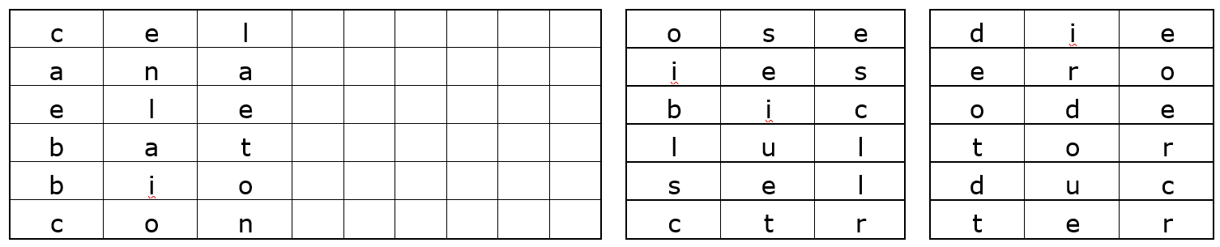

Form six 9-letter words by combining two of the twelve 3-letter block
combinations shown below (right) with each 3-letter block in middle of the grid.
All blocks will be used. If you do it correctly, one of the vertical columns will
spell a common English word describing what teenagers usually make. 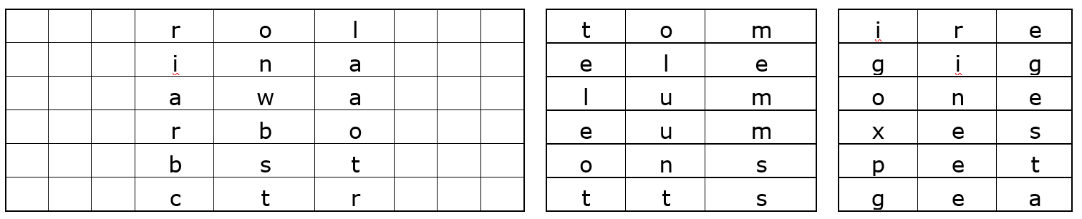

Form six 9-letter words by combining two of the twelve 3-letter block combinations
shown below (right) with each beginning in the grid. All blocks will be used. If you
do it correctly, one of the vertical columns will spell a common English word
describing a person who might make you feel better.
