5x5 Game

Start from the top and choose one letter from each successive row to form
five 5-letter words associated with visible energy. You may jump to any
column as you go down. There is never a need to rearrange the letters,
and every letter will be used exactly once. What are the five words?

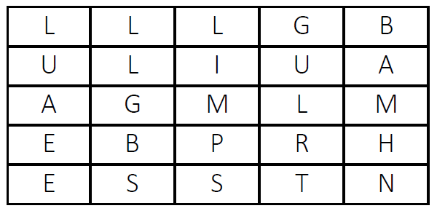
Start from the top and choose one letter from each successive row to form
five 5-letter words associated with power. You may jump to any column as
you go down. There is never a need to rearrange the letters, and every
letter will be used exactly once. What are the five words?

