Draw a line through each word as you find it. The remaining letters are an anagram for a device used to maintain the proper current in some lamp types.
Lighting Word Search and Anagram

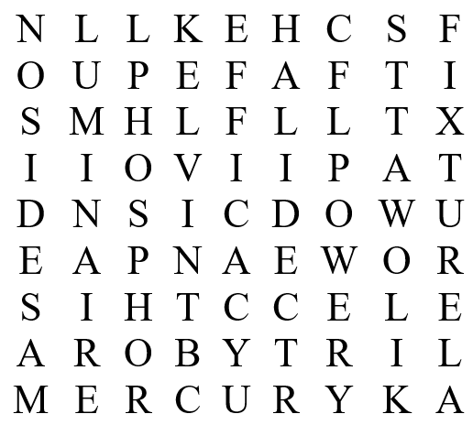
Words to Find:  CCT | Phosphor | Anagram:
CFL | Power
Edison | Halide | _ _ _ _ _ _ _
Efficacy | Kelvin
Fixture | Kilowatts
Mercury | Luminaire

