**🌀 Build-a-Turbine Relay: Lesson Plan (Grades 4-5)**

**Overview:**

Students compete in teams to complete turbine engineering challenges. Each challenge reinforces concepts of design, energy transfer, and efficiency. At the end, they assemble and label a turbine drawing, then justify their design choices.

****NGSS Standards****

***Grade 4***

* **4-PS3-4**: Apply scientific ideas to design, test, and refine a device that converts energy from one form to another.
* **3-5-ETS1-1**: Define a simple design problem reflecting a need or a want that includes specified criteria for success and constraints on materials, time, or cost.

#### **Grade 5**

* **5-PS1-3**: Make observations and measurements to identify materials based on their properties.
* **3-5-ETS1-2**: Generate and compare multiple possible solutions to a problem based on how well each is likely to meet the criteria and constraints.

**Disciplinary Core Ideas (DCI)**

* **PS3.B: Conservation of Energy and Energy Transfer**  
  Energy can be moved from place to place by moving objects or through sound, light, or electric currents.
* **ETS1.A: Defining and Delimiting Engineering Problems**  
  The success of a designed solution is determined by testing and criteria such as stability and function.
* **ETS1.B: Developing Possible Solutions**  
  Testing a solution helps determine how well it solves the problem.
* **ESS3.A: Natural Resources**  
  Energy resources are used to meet human needs, and renewable sources such as wind can reduce impacts.

**Science & Engineering Practices (SEPs)**

* **Planning and Carrying Out Investigations** – Students test base/tower stability, blade movement, and balance in stations.
* **Using Mathematics and Computational Thinking** – Students calculate steps for tower height, and revolutions per minute.
* **Constructing Explanations and Designing Solutions** – Students explain why each turbine part is important and design their final turbine.
* **Obtaining, Evaluating, and Communicating Information** – Students record answers, share with teammates, and present a final labeled turbine design.

**Crosscutting Concepts (CCC)**

* **Cause and Effect** – Strong base = stability; faster blades = more RPM; design choices affect turbine performance.
* **Scale, Proportion, and Quantity** – Tower height modeled at 1/10 scale, blade length scaled down.
* **Systems and System Models** – Turbine as a system of interdependent parts (base, tower, nacelle, blades, rotor).
* **Structure and Function** – Each turbine part has a structure that supports a specific function (e.g., nacelle houses generator, blades capture wind).

**Learning Goals:**

* Parts and functions of a wind turbine
* Teamwork and communication
* Application of basic math and science concepts
* Physical activity and outdoor learning

**Time Length:**

* 40 minutes-45 minutes

**Prep:**

**Materials:**

* **6 stations signs**: Base, Tower, Nacelle, Blades, Rotor, Final Station
* **Challenge cards** (details below)
* **Turbine part cards or cutouts** (for each team) 5 total of each and bonus card
* **Clipboards, paper, and pencils** for group sheet
* **6 station baskets**
* **1 cones or markers**
* **Legos or Knex and paper towel rolls**
* **Stopwatches**
* **2 Calculators**
* **5 Post It Poster Papers**
* **Markers**
* **Turbine parts with definitions**
* **Measuring Wheel**
* **Key for any Adults present**
* **5 Clothes pins or clips**
* **Group Worksheet (enough for 5 groups)**
* **Group Puzzle sheet (enough for 5 groups)**

**Teams:** Divide students into teams of 4–6 (depending on your group size).  
**Set-up:** Place each station a good distance apart (30–50 feet) to promote movement.

**Relay Instructions**

**0–5 min: Introduction**

* Quickly explain what a wind turbine is and introduce each major part. (This will already be done with Be the Blade Activity
  + <https://kansasenergyprogram.org/educators/activities-and-curricula/be-blade-activity>
* Explain that each team must complete 5 challenges to earn all the turbine parts in 20 mins
  + If they don’t finish in time, they will draw only the parts they receive in their final drawing.
* Final task: Draw a full labeled wind turbine using the parts they’ve earned.

**Stations & Challenges**

*(20 minutes total — 4 minutes per station)*

* **Turbine Relay Instructions**

You have two options for how students move through the stations:

**Option 1: Timed Free-for-All**

* Give students **20 minutes** to complete as many stations as they can.
* This option requires **more materials** at each station.
* To manage crowding, limit each station to **no more than two groups** at a time.

**Option 2: Structured Rotation**

* Students spend **4 minutes at each station**, rotating when the timer goes off.
* This option helps ensure all students visit the same number of stations and avoids traffic jams.

**At Each Station:**

* A **labeled sign**
* **One challenge** to complete

**Final Destination Instructions:**

* The **turbine part card** will be collected once the challenge is completed.
* They will **only receive cards that match the stations they've marked** on their worksheet.

Cards for Free Rotation through Stations-Cut Below

**BASE Station — *Balance & Stability Challenge***

🎯 **Goal:** Build a strong base to support a paper towel roll.

🛠️ **What to Do:**

* Use the tray materials to create a base that can hold a paper towel roll upright.
  + ***Structure must be off the ground and able to be blown on without tipping over.***
* 💬 **Discuss:** Why is the base important for real turbines?  
  ✏️ Write your answer (at least one sentence!) on your group sheet.

✅ **To Earn Your BASE Card:**

* Get your structure and answer checked by an adult.
* Once approved:  
  🔄 Take your base apart  
  🎴 Visit the **Card Holder** and collect your **BASE card**  
  ➡️ Head to **Station #2**!

🌀 **Tip:** Think about wind, ground, and balance!

💫 **If you’ve earned all 5 cards…**  
🎉 Ask for your **Final Destination Card** and proceed to the **FINAL STATION**!

**📏 TOWER Station — *Quick Math in Action!***

🎯 **Goal:** Measure out a turbine's height—then solve a real-world math challenge!

🛠️ **What to Do:**

* A turbine is 80 meters tall. Use the measuring wheel to mark out **8 meters** (1/10 scale).
* Drop your cone at that spot!
* Now solve:  
  ❓ *If your pace is 1 meter, how many steps to walk the tower height?*  
  ✏️ Write the answer on your group sheet.

✅ **To Earn Your TOWER Card:**

* Get your cone placement and math answer checked.
* Clean up your tools and return them to the station.
* 🎴 Visit the **Card Holder** and collect your **TOWER card**  
  ➡️ Head to **Station #3**!

🌀 **Tip:** Count your steps carefully—you’re a human measuring stick!

💫 **If you’ve earned all 5 cards…**  
🎉 Ask for your **Final Destination Card** and proceed to the **FINAL STATION**!

**⚙️ NACELLE Station — *Function Match Game***

🎯 **Goal:** Learn what powers the turbine from the inside out.

🛠️ **What to Do:**

* Match turbine **parts** with their correct **functions** using the cards and clips.
* Then, write the correct function of the nacelle:

✅ **To Earn Your NACELLE Card:**

* Show your match-ups and sentence to an adult.
* Return all items neatly to the basket.
* 🎴 Grab your **NACELLE card** from the **Card Holder**  
  ➡️ Head to **Station #4**!

🌀 **Tip:** Think of the nacelle as the brain of the turbine!

💫 **If you’ve earned all 5 cards…**  
🎉 Ask for your **Final Destination Card** and proceed to the **FINAL STATION**!

**💨 BLADES Station — *Spin into Motion!***

🎯 **Goal:** Simulate blade movement and calculate RPM.

🛠️ **What to Do:**

* One teammate becomes the blade—spin slowly with arms out.
* Others count revolutions for 10 seconds using the stopwatch.
* Use the calculator to figure out **RPM (Revolutions per Minute)**.  
  ✏️ Record the answer on your group sheet.
* Bonus Q: *Why do blades spin at different speeds in different winds?*

✅ **To Earn Your BLADES Card:**

* Spin ✅
* RPM answer ✅
* Bonus answer = 🎉 **Bonus card**!
* Reset the station before you leave.
* 🎴 Visit the Card Holder and collect your **BLADES card** (and **Bonus card** if you earned it)  
  ➡️ Head to **Station #5**!

🌀 **Tip:** Use smooth spinning and teamwork for accurate results.

💫 **If you’ve earned all 5 cards…**  
🎉 Ask for your **Final Destination Card** and proceed to the **FINAL STATION**!

**🧩 ROTOR Station — *Word Puzzle***

**🎯 Goal:**  
Understand what the **rotor** does and how it helps generate energy.

### 📝 What to Do:

1. **Grab the laminated word search** at the station.
2. **Find all the words** listed at the bottom by circling them with an expo marker in the station box.
3. When you're finished, **use at least 4 words you found** to write **one sentence** that explains what a rotor does.  
   ✏️ **Underline** each word in your sentence.

### ⏱️ Finished Early?

Use your bodies to **act out the motion of a rotor**:

* Everyone in your group must **work together as a spinning unit**.
* Be creative—show **rotation, energy, motion, or wind**!

✅ **To Earn Your ROTOR Card:**

* **Get your puzzle and sentence checked** by an adult
* **Bonus Card is earned-**if an adult sees your Rotor Motion
* Erase the word search Sheet
* Put everything back in the station box
* 🎴 Visit the Card Holder to receive your **ROTOR card**  
  ➡️ Head to **Station #1**!

💫 **If you’ve earned all 5 cards…**  
🎉 Ask for your **Final Destination Card** and proceed to **the FINAL STATION**!

**🏁 Final Destination Station — *Creative Turbine Time!***

🖍️ **Use Your Cards to Design Your Turbine!**

* Grab large Post-It paper and markers
* Draw and label your complete turbine using only the parts you earned:  
  ✅ BASE  
  ✅ TOWER  
  ✅ NACELLE  
  ✅ BLADES  
  ✅ ROTOR
* Use your **Bonus Card** for a missing part *or* a creative add-on (like lightning protection or bird-safe blades!).

✨ Don’t forget:

* Label every part
* Add a cool turbine name
* Use colors, creativity, and teamwork!

**Alternate Station Cards-for 4 min. rotations**

**🌟#1 BASE Station — *Balance & Stability Challenge***

🎯 **Goal:** Build a strong base to support a paper towel roll.

🛠️ **What to Do:**

* Use the tray materials to create a base that can hold a paper towel roll upright.
  + ***Structure must be off the ground and able to be blown on without tipping over.***
* 💬 **Discuss:** Why is the base important for real turbines?  
  **✏️ Write your answer (at least one sentence!) on your group sheet.**

✅ **To Earn Your BASE Card:**

* Get your structure and answer checked by an adult.
* Once approved:  
  🔄 Take your base apart
* 📝 Make sure the adult **adds a checkmark** to your group sheet.
* ⏱️ **Stop and wait** for the timer before moving on.
* ➡️ Head to **Station #2**!

🌀 **Tip:** Think about wind, ground, and balance!

💫 **If you’ve earned all 5 cards…**Proceed to the **FINAL STATION**!

**📏 #2 TOWER Station — *Quick Math in Action!***

🎯 **Goal:** Measure out a turbine's height—then solve a real-world math challenge!

🛠️ **What to Do:**

* A turbine is 80 meters tall. Use the measuring wheel to mark out **8 meters** (1/10 scale).
* Drop your cone at that spot!
* Now solve:  
  ❓ *If your pace is 1 meter, how many steps to walk the tower height?*  
  **✏️ Write the answer on your group sheet.**

✅ **To Earn Your TOWER Card:**

* Get your cone placement and math answer checked.
* Clean up your tools and return them to the station.
* 📝 Make sure the adult **adds a checkmark** to your group sheet.
* ⏱️ **Stop and wait** for the timer before moving on.
* ➡️ Head to **Station #3**!

🌀 **Tip:** Count your steps carefully—you’re a human measuring stick!

💫 **If you’ve earned all 5 cards…**Proceed to the **FINAL STATION**!

**⚙️#3 NACELLE Station — *Function Match Game***

🎯 **Goal:** Learn what powers the turbine from the inside out.

🛠️ **What to Do:**

* Match turbine **parts** with their correct **functions** using the cards and clips.
* **Then, write the correct function of the nacelle:**

✅ **To Earn Your NACELLE Card:**

* Show your matchups and sentence to an adult.
* Return all items neatly to the basket.
* 📝 Make sure the adult **adds a checkmark** to your group sheet.
* ⏱️ **Stop and wait** for the timer before moving on.
* ➡️ Head to **Station #4**!

🌀 **Tip:** Think of the nacelle as the brain of the turbine!

💫 **If you’ve earned all 5 cards…**Proceed to the **FINAL STATION**!

**💨#4 BLADES Station — *Spin into Motion!***

🎯 **Goal:** Simulate blade movement and calculate RPM.

🛠️ **What to Do:**

* One teammate becomes the blade—spin slowly with arms out.
* Others count revolutions for 10 seconds using the stopwatch.
* Use the calculator to figure out **RPM (Revolutions per Minute)**.  
  **✏️ Record the answer on your group sheet**.
* **Bonus Q:** *Why do blades spin at different speeds in different winds?*

✅ **To Earn Your BLADES Card:**

* Spin ✅
* RPM answer ✅
* Bonus answer = 🎉 **Bonus card**!
* Reset the station before you leave.
* 📝 Make sure the adult **adds a checkmark** to your group sheet and mark if you receive the Bonus Card.
* ⏱️ **Stop and wait** for the timer before moving on.
* ➡️ Head to **Station #5**!

🌀 **Tip:** Use smooth spinning and teamwork for accurate results.

💫 **If you’ve earned all 5 cards…**Proceed to the **FINAL STATION**!

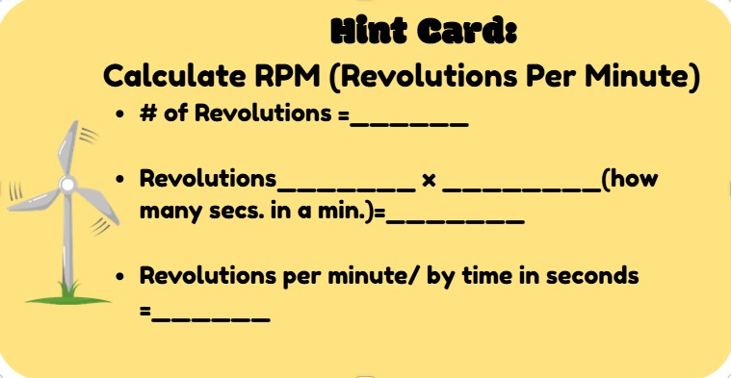

**🧩 #5 ROTOR Station — *Word Puzzle***

**🎯 Goal:**  
Understand what the **rotor** does and how it helps generate energy.

### 📝 What to Do:

1. **Grab the laminated word search** at the station.
2. **Find all the words** listed at the bottom by circling them with a expo marker in the station box.
3. When you're finished, **use at least 4 words you found** to write **one sentence** that explains what a rotor does.  
   ✏️ **Underline** each word in your sentence.

### ⏱️ Finished Early? BONUS

Use your bodies to **act out the motion of a rotor**:

* Everyone in your group must **work together as a spinning unit**.
* Be creative—show **rotation, energy, motion, or wind**!

✅ **To Earn Your ROTOR Card:**

* **Get your puzzle and sentence checked** by an adult
* **Bonus Card is earned-**if an adult sees your Rotor Motion
* Erase the word search Sheet
* Put everything back in the station box
* **Stop and wait** for the timer before moving on.
* ➡️ Head to **Station #1**!

💫 **If you’ve earned all 5 cards…**Proceed to **the FINAL STATION**!

**🏁 Final Destination Station — *Creative Turbine Time!***

🖍️ **Instructions:**

🧾 **Step 1: Get your cards!**  
🎴 Visit the **Card Keeper** and collect all the cards you earned during your station rotations:  
✅ BASE  
✅ TOWER  
✅ NACELLE  
✅ BLADES  
✅ ROTOR  
✨ BONUS (if earned)

📝 **Step 2: Gather materials**  
• Large Post-It paper  
• Markers

🎨 **Step 3: Build your turbine**  
• Draw and **label** your turbine using ONLY the parts you earned.  
• Use your **Bonus Card** to:

* Add a missing part **OR**
* Create a cool upgrade (like lightning protection or bird-safe blades!)

💡 **Step 4: Get creative!**  
• Color code parts  
• Name your turbine  
• Add fun extras like a logo or slogan!

**Wind Turbine Station Group Worksheet – Answer Key**

**🌟#1 BASE Station — *Balance & Stability Challenge***

🎯 **Goal:** Build a strong base to support a paper towel roll.

🛠️ **What to Do:**

* Use the tray materials to create a base that can hold a paper towel roll upright.
  + ***Structure must be off the ground and able to be blown on without tipping over.***
* 💬 **Discuss:** Why is the base important for real turbines?  
  ✏️ Write your answer (at least one sentence!) on your group sheet.

✅ **To Earn Your BASE Card:**

* Get your structure and answer checked by an adult.
* Once approved:  
  🔄 Take your base apart
* 📝 Make sure the adult **adds a checkmark** to your group sheet.
* ⏱️ **Stop and wait** for the timer before moving on.
* ➡️ Head to **Station #2**!

🌀 **Tip:** Think about wind, ground, and balance!

💫 **If you’ve earned all 5 cards…**  
🎉 Ask for your **Final Destination Card** and proceed to the **FINAL STATION**!

ANSWER:

**Q: Why is the base important for real turbines?**

**A: The base keeps the turbine stable and prevents it from tipping over.**

**Structure must be off the ground and able to be blown on without tipping over.**

**📏 #2 TOWER Station — *Quick Math in Action!***

🎯 **Goal:** Measure out a turbine's height—then solve a real-world math challenge!

🛠️ **What to Do:**

* A turbine is 80 meters tall. Use the measuring wheel to mark out **8 meters** (1/10 scale).
* Drop your cone at that spot!
* Now solve:  
  ❓ *If your pace is 1 meter, how many steps to walk the tower height?*  
  ✏️ Write the answer on your group sheet.

✅ **To Earn Your TOWER Card:**

* Get your cone placement and math answer checked.
* Clean up your tools and return them to the station.
* 📝 Make sure the adult **adds a checkmark** to your group sheet.
* ⏱️ **Stop and wait** for the timer before moving on.
* ➡️ Head to **Station #3**!

🌀 **Tip:** Count your steps carefully—you’re a human measuring stick!

💫 **If you’ve earned all 5 cards…**  
🎉 Ask for your **Final Destination Card** and proceed to the **FINAL STATION**!

ANSWER:

Q: How many steps would you take to walk 80 meters?

A: 80 steps (1 step = 1 meter).

**⚙️#3 NACELLE Station — *Function Match Game***

🎯 **Goal:** Learn what powers the turbine from the inside out.

🛠️ **What to Do:**

* Match turbine **parts** with their correct **functions** using the cards and clips.
* Then, write the correct function of the nacelle:

✅ **To Earn Your NACELLE Card:**

* Show your match-ups and sentence to an adult.
* Return all items neatly to the basket.
* 📝 Make sure the adult **adds a checkmark** to your group sheet.
* ⏱️ **Stop and wait** for the timer before moving on.
* ➡️ Head to **Station #4**!

🌀 **Tip:** Think of the nacelle as the brain of the turbine!

💫 **If you’ve earned all 5 cards…**  
🎉 Ask for your **Final Destination Card** and proceed to the **FINAL STATION**!

**ANSWER:**

|  |  |
| --- | --- |
| BLADES | Long arms that catch wind and begin the turbine's  rotation. |
| ROTOR | Spins with the blades and connects to the shaft to  power the turbine. |
| NACELLE | The housing that holds the gearbox, generator, and  control system. |
| GENERATOR | Converts the spinning motion into electrical energy. |
| BASE | Heavy foundation that keeps the turbine stable and  upright. |
| TOWER | Tall support that lifts the blades higher into  stronger wind. |

This answer must be on their sheet

Q: What is the function of the nacelle?

**A: Holds the gearbox, generator, and controls.**

**💨#4 BLADES Station — *Spin into Motion!***

🎯 **Goal:** Simulate blade movement and calculate RPM.

🛠️ **What to Do:**

* One teammate becomes the blade—spin slowly with arms out.
* Others count revolutions for 10 seconds using the stopwatch.
* Use the calculator to figure out **RPM (Revolutions per Minute)**.  
  ✏️ Record the answer on your group sheet.
* Bonus Q: *Why do blades spin at different speeds in different winds?*

✅ **To Earn Your BLADES Card:**

* Spin ✅
* RPM answer ✅
* Bonus answer = 🎉 **Bonus card**!
* Reset the station before you leave.
* 📝 Make sure the adult **adds a checkmark** to your group sheet and mark if you receive the Bonus Card.
* ⏱️ **Stop and wait** for the timer before moving on.
* ➡️ Head to **Station #5**!

🌀 **Tip:** Use smooth spinning and teamwork for accurate results.

💫 **If you’ve earned all 5 cards…**  
🎉 Ask for your **Final Destination Card** and proceed to the **FINAL STATION**!

**ANSWER:**

Q: Calculate RPM (e.g., 5 revolutions in 10 sec)?

# of rotations x 60 (5 x 60)= 300

300/ 10

**A: 30 RPM (5 rev × 6 = 30 RPM).**

**BONUS:**

Q: Why do blades spin slower or faster in different wind speeds?

A: Wind speed affects force on the blades—more wind = faster spin

Hint Card is given in the box to actually figure out the answer:



**🧩 #5 ROTOR Station — *Word Puzzle***

**🎯 Goal:**  
Understand what the **rotor** does and how it helps generate energy.

### 📝 What to Do:

1. **Grab the laminated word search** at the station.
2. **Find all the words** listed at the bottom by circling them with a expo marker in the station box.
3. When you're finished, **use at least 4 words you found** to write **one sentence** that explains what a rotor does.  
   ✏️ **Underline** each word in your sentence.

### ⏱️ Finished Early? BONUS

Use your bodies to **act out the motion of a rotor**:

* Everyone in your group must **work together as a spinning unit**.
* Be creative—show **rotation, energy, motion, or wind**!

✅ **To Earn Your ROTOR Card:**

* **Get your puzzle and sentence checked** by an adult
* **Bonus Card is earned-**if an adult sees your Rotor Motion
* Erase the word search Sheet
* Put everything back in the station box
* **Stop and wait** for the timer before moving on.
* ➡️ Head to **Station #1**!

💫 **If you’ve earned all 5 cards…**Proceed to **the FINAL STATION**!

**ANSWER:**

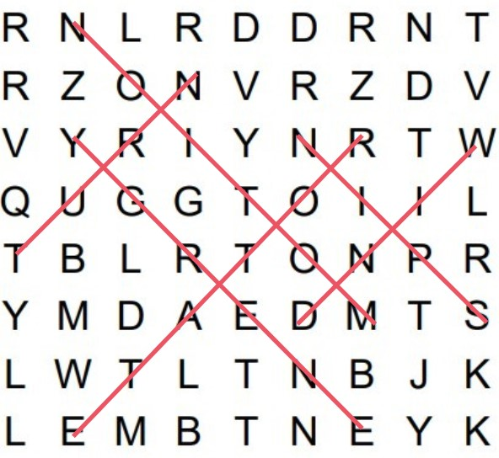

Sentence:

Some options:

* *The* ***rotor*** *uses the* ***wind*** *to* ***spin*** *and* ***rotate****, creating* ***motion*** *that is turned into* ***energy****.*
* *The* ***wind*** *makes the rotor* ***spin*** *and* ***turn*** *to make* ***energy****.*
* *As the* ***wind*** *blows, the rotor* ***spins*** *and* ***rotates****, creating* ***motion*** *that is converted into useful* ***energy.***

**Bonus:** They spin all together around one person

**🏁 Final Destination Station — *Creative Turbine Time!***

🖍️ **Instructions:**

🧾 **Step 1: Get your cards!**

* **Lay all the cards and bonus cards on the ground**
* **Easiest is to have one person come up to the Card Keeper and show you what they earned, then let them pick up the ones they need and take it back to the group for the picture.**   
  🎴 Visit the **Card Keeper** and collect all the cards you earned during your station rotations:  
  ✅ BASE  
  ✅ TOWER  
  ✅ NACELLE  
  ✅ BLADES  
  ✅ ROTOR  
  ✨ BONUS (if earned)

📝 **Step 2: Gather materials**  
• Large Post-It paper  
• Markers

🎨 **Step 3: Build your turbine**  
• Draw and **label** your turbine using ONLY the parts you earned.  
• Use your **Bonus Card** to:

* Add a missing part **OR**
* Create a cool upgrade (like lightning protection or bird-safe blades!)

💡 **Step 4: Get creative!**  
• Color code parts  
• Name your turbine  
• Add fun extras like a logo or slogan!

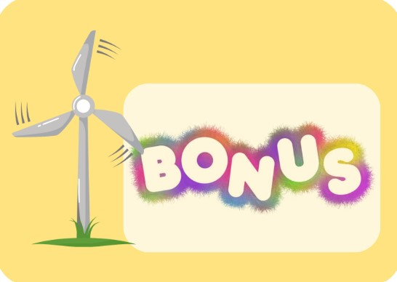





­­­Rotor Word Search

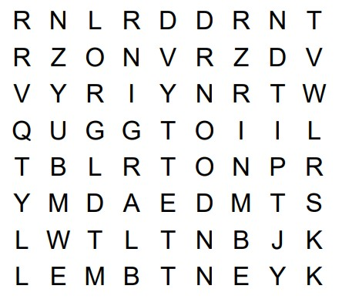

Spin Turn Rotate

Motion Energy Wind

