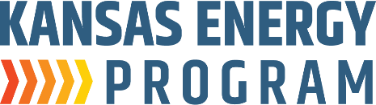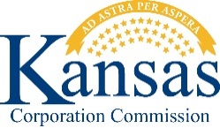

***Sponsored by the K-State Engineering Extension’s Kansas Energy Program and the Kansas Corporation Commission:***

**K-12 Energy Benchmarking Project Workshop**

**Organizers/Speakers from the Kansas Energy Program:**

* David Carter
* Kurt Foley
* Ryan Hamel
* Mandy Putnam
* Stacy Harris

**When:** Wednesday, September 24th, 9:00am – 4:00pm (6 hours)

**Where:** K-State Innovation Center  
 2005 Research Park Circle

Manhattan, KS 66502

**Cost:** Free

**Continuing Professional Competency Activity Attendance Verification**

The workshop presented as part of the K-12 Energy Benchmarking Project is intended to provide the number of contact hours shown above and the opportunity for you to earn the equivalent number of Professional Development credit hours. *It is your responsibility to certify the time you actually spent in attendance and the applicability of the content to your field of practice.*

I certify that I spent hours in attendance of the above program, and I further certify that the presented material assisted me in maintaining, improving, or expanding the skills and knowledge related to my field of practice.

Participant Name: ­­­­­­­­­­­­­­­­­­­­­­­­­­­­­­­­­­­­­­­­___________________________________________________________  (Print)

__________________________________________________________________________

(Signature)

Attendance verified by: f

(Signature)